**Slack ID: CoBird**

**Track: Data Analysis**

**Stage: Stage 3 task**

**SQL BASICS AND MARKETING-SPECIFIC QUERIES**

**Introduction**

Exploratory data analysis and insight generation were conducted on a large marketing campaign dataset. The objective of this project was to perform database manipulation and insight extraction on the provided [marketing data](https://docs.google.com/spreadsheets/d/1LBGqmX9jT6HuJwHrVZXjIKPxqElkYFPg/edit?usp=drive_link&ouid=102606023409835819338&rtpof=true&sd=true) using the PostgresSql database management tool.

**Methodology**

The following database loading and manipulation techniques were conducted on the data set:

1. Data loading: The CSV file containing the dataset was loaded into the PostgresSql server using lines of code contained in the screenshot below

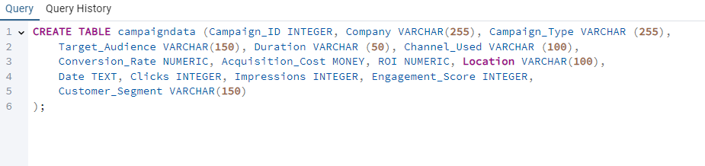

1. After successfully loading the dataset, relevant and appropriate codes were used to extract useful data and gain insights into the performance of the marketing campaign
2. The first objective in the data exploration process is to calculate the Total Impressions for each campaign. The appropriate SQL query was used and saved as an SQL file with the appropriate file name. The query yielded 200,005 rows of campaign id with the sum of impressions each of the campaign_id’s had stored in a column called ‘totalimpressions’. Screenshots are provided below:

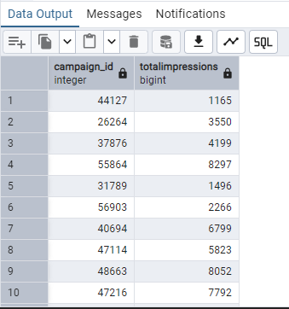

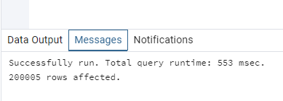

1. The next step in the data exploration process was to identify the campaign and company that generated the highest ROI. The script used to execute this query is saved in the appropriate SQL file. As seen from the screenshot below, campaign_id 168 conducted by the company NextGen Systems has the highest ROI:

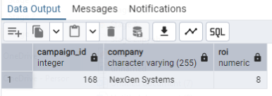

1. The three locations with the highest total impressions from the campaign were also determined using the appropriate query syntax. The locations, arranged in order from the highest impressions to the third highest impressions are New York, Miami, and Chicago as seen from the screenshot below:

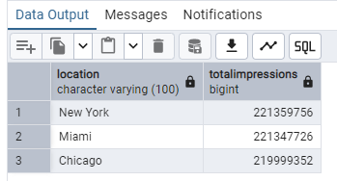

1. The average engagement score for each target audience was also examined using the appropriate PostgresSql query. The query took 259 msecs to execute and returned the average engagement scores of each of the target audiences as illustrated in the screenshots below:

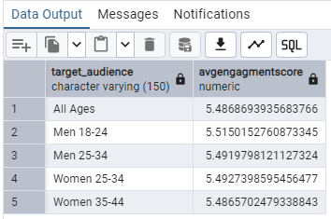

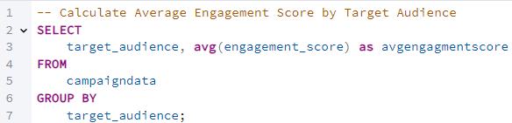

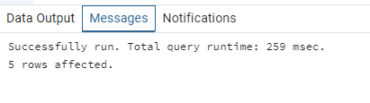

1. The overall click-through-rate of the campaign was further extracted from the database using the appropriate PostgresSql query. To ensure the accuracy of the result, the sum of the number of clicks was first converted to a float data type. The result of the query revealed that the overall CTR of the campaign is 9.9826 to 4 decimals.

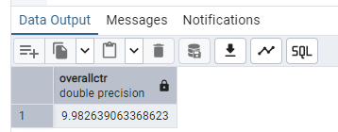

1. The relevant PostgresSql query was used to determine the company and campaign ID with the greatest campaign effectiveness by relying on the ratio of acquisition cost to the conversion rate of the campaign. It was gathered that campaign ID 170866, run by NextGen Systems, was the most effective campaign with a cost-per-conversion ratio of $2 million.

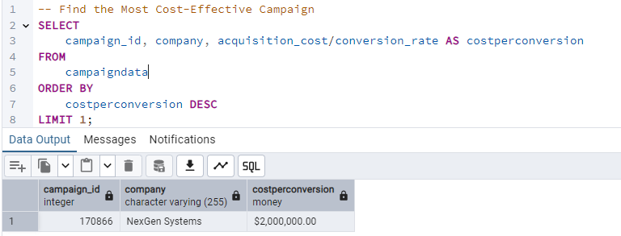

1. A 5% click-through-rate threshold was chosen to investigate the effectiveness of the campaign and the relevant query was used to extract company names and the campaign ID of campaigns that exceed the threshold. It was found that 160,332 campaigns exceeded the 5% CTR threshold as shown below

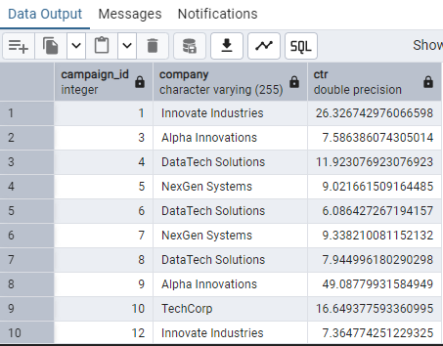

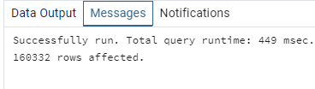

1. Finally, the conversion rate per channel was used to rank the performance of the campaign across each of the channels used for the campaign. Using the appropriate PostgresSql query, it was discovered that Emails had the highest conversions of all the channels used for the marketing (2,697.38). This was followed by Google Ads (2,681.24) and then Websites (2,674.95), while YouTube (2,667.76), Instagram (2,667.57), and Facebook (2,625.27) had the lowest three total conversion rates.

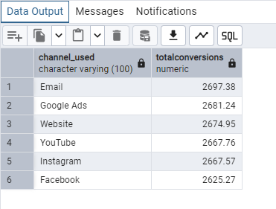

**Conclusion and Recommendations**

The result of the data exploration revealed that the campaign run by NextGen Systems yielded the highest ROI. Additionally, of all the companies the marketing campaign was run in favor of, the NextGen Systems campaign delivered the most effective campaign by achieving the highest cost-per-conversion ratio of $2 million. From these, it is recommended that the campaign strategies employed by NextGen systems be studied and useful distinguishable features that made their campaign highly effective be drawn and incorporated into the marketing campaigns run by other companies.

From the exploration of the database, it was also gathered that campaigns targeted towards men aged 18-24 have the highest average engagement score (5.515), and that of all the channels used for the marketing campaigns, emails, google ads, and websites generated the highest number of impressions (in decreasing order). From the above, it is recommended that for greater campaign effectiveness especially when on a tight marketing budget, companies should ensure to make their campaigns to target more persons who are men and within the age of 18-24, as this demographic is known to engage more with campaigns. Similarly, such tight-budget campaigns should prioritize the use of emails, Google ads, and websites in their marketing efforts rather than using channels like YouTube and Instagram.

Additional analysis of the database revealed that the campaigns had an overall ctr of over 9%. This implies that generally, the campaigns had effective targeting and a strong ad relevance to the target audience. In terms of location, the campaigns were found to generate the highest impressions in New York, Miami, and Chicago (in descending order). Accordingly, it is recommended that proper follow-up activities like running promos, providing vouchers, etc., be immediately embarked on in these states to turn these impressions into leads.